

**UNIVERSIDAD PRIVADA DE TACNA**

**FACULTAD DE INGENIERIA**

**Escuela Profesional de Ingeniería de Sistemas**

**TRABAJO ENCARGADO**

Curso: Inteligencia de Negocios

Docente: Ing. Patrick Cuadros Quiroga

**Willian, Huillca Umpiri (2015053793)**

**Tacna – Perú**

**2020**

# PRACTICA DE LABORATORIO N° 02

**Creando un Reporte Interactivo en Power BI**

### OBJETIVOS

* + A. Elaboración de reportes con Power BI con base de datos SQL.

### REQUERIMIENTOS

* + Conocimientos

Para el desarrollo de esta práctica se requerirá de los siguientes conocimientos básicos:

* + - Conocimientos básicos de administración de base de datos Microsoft SQL Server.
    - Conocimientos básicos de SQL.
  + Software

Asimismo se necesita los siguientes aplicativos:

* + - Microsoft SQL Server 2016 o superior
    - Base de datos AdventureWorksLT2016 o superior
    - Tener los archivos de recursos del laboratorio.
    - Power BI Desktop.
    - Tener una cuenta Microsoft registrada en el Portal de Power Bi

### CONSIDERACIONES INICIALES

* + Generar una carpeta o directorio Power BI en un lugar accesible para guardar los resultados de la práctica.

### DESARROLLO

Ejercicio 1: Conectando a Power BI a datos

Tarea 1: Conectar a datos existentes

1. Abrir SQL Server Management Studio, y conectar a la instancia de base de datos **(local)** utilizando autenticación de Windows.
2. En el menú Archivo (**File)**, en el submenu Abrir (**Open)**, hacer click en **Project/Solution**, y buscar el archivo

**Project.ssmssln**.

1. En el Explorador de Soluciones, expandir Consultas (**Queries)**, y luego hacer doble click en el archivo **Lab Exercise 1.sql**.
2. Abrir **Power BI Desktop**.
3. En la ventana Power BI Desktop, hacer click en Obtener Data (**Get Data)**.
4. En el cuadro Obtener Datos, click base de datos **Microsoft SQL**, y entonces click en Conectar
5. En la ventana base de datos Server database, En **Servidor**, escribir (**local)**.
6. En **Base de Datos (opcional)**, tipear **AdventureWorksLT**.
7. Expandir el cuadro **Opciones Avanzadas**. Copiar el script **Task 1** del archivo **Lab Exercise 1.sql**. y pegar la consulta en Power BI, en el cuadro sentencia SQL. Luego presionar OK.
8. En la ventana de vista preliminar click en Cargar.
9. En Power BI Desktop, click **Obtener Datos** y luego click en Mas.
10. Repetir los pasos del 6 al 10, utilizando el script **Task 2.**
11. De regreso en el reporte. Guardar el archivo como **AdventureWorksLT Sales.pbix**.

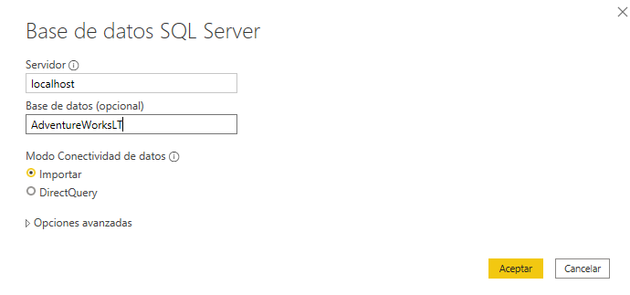

Tarea 2: Graficar Datos

1. En el panel Campos (Fields), click derecho sobre Query1, Renombrar, tipear Customers y presionar Enter.
2. Para el Query2, hacer lo mismo del paso 1 y colocar el nombre Sales.
3. Expandir ambas tablas para ver todas las filas.
4. En la barra de navegación, click Datos (Data).
5. In the Fields pane, click the Customers table, if it is not already selected.
6. Right-click the NameStyle column, and click Delete.
7. 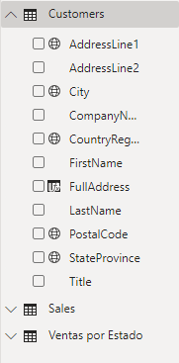In the Delete Column dialog box, click Delete.
8. Repetir el paso 6 y 7 para la columna SalesPerson.
9. Right-click the CustomerID column, and then click Hide in Report View.
10. Click the AddressLine1 column header.
11. On the Modeling ribbon, in the Properties group, click Data Category: Uncategorized, and then click Address.
12. Click the City column header.
13. On the Modeling ribbon, in the Properties group, click Data Category: Uncategorized, and then click City.
14. Click the StateProvince column header.
15. On the Modeling ribbon, in the Properties group, click Data Category: Uncategorized, and then click State or Province.
16. Click en el encabezado de columna CountryRegion.
17. On the Modeling ribbon, in the Properties group, click Data Category: Uncategorized, and then click Country/Region.
18. Click en el encabezado de columna PostalCode.
19. On the Modeling ribbon, in the Properties group, click Data Category: Uncategorized, and then click Postal Code.
20. On the Modeling ribbon, in the Calculations group, click New Column, and then in the formula bar, type the following expression and press Enter:

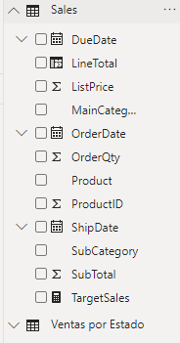 FullAddress = Customers[AddressLine1] & ", " & Customers[City] & ", " & Customers[StateProvince] & ", " & Customers[CountryRegion] & ", " & Customers[PostalCode]

1. In the Fields pane, click Sales.
2. Right-click the RevisionNumber column, and click Delete.
3. In the Delete Column dialog box, click Delete.
4. Realizar el paso 23 y 34 para la columna SalesOrderNumber.
5. Right-click the CustomerID column, and then click Hide in Report View.
6. Realizar el paso 26 para las columnas SalesOrderID y SalesOrderDetailID.
7. On the Modeling ribbon, in the Calculations group, click New Column, and then in the formula bar, type the following expression and press Enter:

LineTotal = Sales[OrderQty] * Sales[ListPrice]

1. Click the LineTotal column header.
2. On the Modeling ribbon, in the Formatting group, click Format: General, point to Currency, and then click $ English (United States).
3. On the Modeling ribbon, in the Calculations group, click New Measure, and then in the formula bar, type the following expression and press Enter.

TargetSales = SUM('Sales'[LineTotal]) * 1.2

1. Click Save, and then leave Power BI Desktop open for the next task.

## Tarea 3: Combinar Data

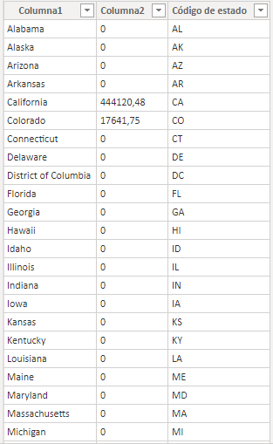

1. In File Explorer, and then open the States.xlsx file.
2. In the States worksheet, select all of the values in the two columns, and then press Ctrl+C.
3. In Power BI Desktop, on the Home ribbon, click Enter Data.
4. In the Create Table dialog box, click in the table, and then press Ctrl+V. Power BI detects that thefirs t row is a column header.
5. In the **Name** box, type **Sales by State**, and then click **Load**.
6. On the **Home** ribbon, click **Get Data**, and then click **Web**.
7. In the **From Web** dialog box, in the **URL** box, type

[**http://en.wikipedia.org/wiki/List_of_U.S._state_abbreviations**,](http://en.wikipedia.org/wiki/List_of_U.S._state_abbreviations) and then click **OK**.

1. In the **Navigator** dialog box, select **Codes and abbreviations for U.S. states, territories and other regions**, and then click **Load**.
2. In the **Fields** pane, click **Codes and abbreviations for U.S. states, territories and other regions** to display the data. The table has 26 rows at the bottom that are not needed.
3. On the **Home** ribbon, in the **External Data** group, click **Edit Queries**, then click **Edit Queries**.
4. In Query Editor, in the **Queries** pane, click **Codes and abbreviations for U.S. states, territories and other regions**.
5. On the **Home** ribbon, click **Reduce Rows**, click **Remove Rows**, and then click **Remove Bottom Rows**.
6. In the **Remove Bottom Rows** dialog box, in the **Number of rows** box, type **26**, and then click **OK**.
7. Click the **ANSI2** column header, and then hold down the Ctrl key while selecting all of the columns to the right. This selects multiple rows.
8. Still holding down Ctrl, click the **Name and status of region2** and **Header** columns to include this in the selection.
9. On the **Home** ribbon, click **Manage Columns**, click **Remove Columns**, and then click **Remove Columns**.
10. In the **Query Settings** pane, under **Properties**, in the **Name** box, type **States with Codes**, and then press Enter.
11. On the **Home** ribbon, in the **Transform** group, click **Use First Row as Headers**.
12. Right-click the **United States of America** column header, click **Rename**, type **State Name**, and then press Enter.
13. 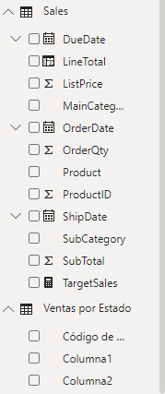Right-click the **US USA 840** column header, click **Rename**, type **State Code Long**, and then press Enter.
14. Right-click the **US** column header, click **Rename**, type **State Code Short**, and then press Enter.
15. In the **Queries** pane, click **Sales by State**.
16. On the **Home** ribbon, click **Combine**, and then click **Merge Queries**.
17. In the **Merge** dialog box, in the **Sales by State** table, click the **States** column.
18. In the list, click **States with Codes**, click the **State Name** column, and then click **OK**. The new column is added to the table and contains the merged **States with Codes** table.
19. In the column header, click the **Expand** icon, clear **(Select All Columns)**, select **State Code Short**, and then click **OK**. The column now shows just the state codes.
20. Right-click the column, click **Rename**, type **State Code**, and then press Enter.
21. On the **File** menu, click **Close & Apply**.
22. In the **Fields** pane, right-click **States with Codes**, and then click **Hide in Report View**.

Ejercicio 2: Construyendo Reportes en Power BI

Tarea 1: Crear un Gráfico

1. En **Power BI Desktop**, en la barra derecha de navegación, hacer click en Reporte (**Report)**.
2. En el panel de Visualizaciones (**Visualizations)**, hacer click en **Gauge**.
3. Arrastar el campo **LineTotal** de la table **Sales** a la propiedad Valor (**Value)** del objeto gauge.
4. Arrastrar la medida **TargetSales** de la table **Sales** a la propiedad Valor destino (**Target value)** del objeto gauge.
5. Hacer click **Format**, exppandir **Gauge axis**, and then in the **Max** box, type **146000**.
6. Expandir Titulo (**Title)**, en el cuadro Texto de Titulo (**Title Text)**, tipear Meta de Ventas (**Target Sales)**, y luego hacer click en **Center**.

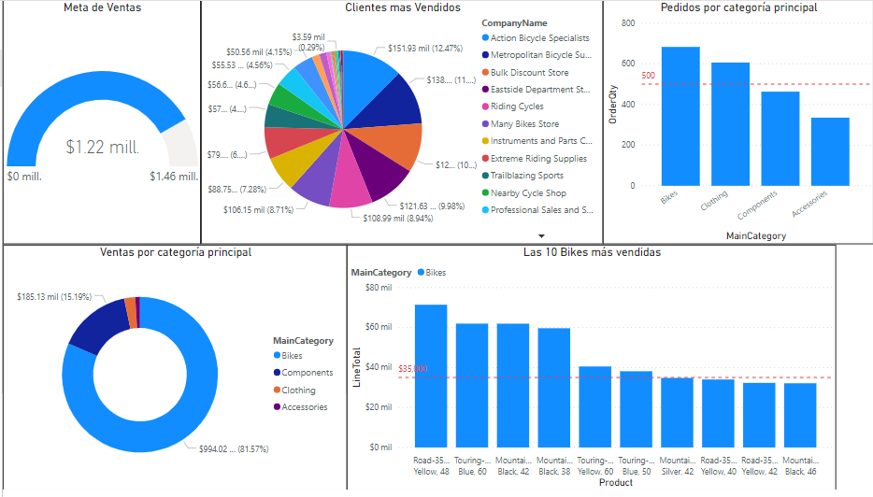

1. Click the report canvas, and then drag the **CompanyName** field from the **Customers** table onto the report. Power BI automatically creates a table.
2. Arrastar the **LineTotal** field from the **Sales** table onto the report.
3. Make sure that the table has focus, and then in the **Visualizations** pane, click **Pie chart**.
4. Expand the chart to make all of the company names visible by using the resizer handles on the edge of the chart.
5. With the focus still on the pie chart, click **Format**, and then expand **Title**.
6. In the **Title Text** box, type **Top Selling Customers**, and then click **Center**.



1. Arrastar el campo **MainCategory** de la tabla **Sales** table onto the report canvas. Power BI creates a table.
2. Arrastar el campo **OrderQty** dentro de la tabla.
3. In the **Visualizations** pane, click **Stacked bar chart**.
4. In the **Visualizations** pane, click **Fields**.
5. Drag the **OrderQty** field onto the **Color saturation** property. Notice that the colors change.
6. In the **Visualizations** pane, click **Analytics**, expand **Constant Line**, and then click **Add**.
7. In the **Value** box, type **500**.
8. Change **Color** to red, toggle **Data label** to **On**, and then change the color to **red**.
9. In the **Visualizations** pane, click **Format**, and expand **Title**.
10. In the **Title Text** box, type **Orders by Main Category**, and then click **Center**.



1. Click the report canvas to give it focus, and then in the **Visualizations** pane, click **Donut chart**.
2. In the **Sales** table, select **MainCategory** and **LineTotal**.
3. In the **Visualizations** pane, click **Format**, and then expand **Title**.
4. In the **Title Text** box, type **Sales by Main Category**, and then click **Center**.



1. Drag the **Product** field from the **Sales** table onto the report canvas. Power BI creates a table.
2. Drag the **LineTotal** field from the **Sales** table onto the products table chart.
3. In the **Sales** table, select the **MainCategory** field.
4. In the **Visualizations** pane, click **Fields**.
5. In the **Filters** pane, expand **LineTotal(All)**.
6. In the **Show items when the value** list, select **is greater than**, and then in the box below, type **32000**.
7. Hacer click en Aplicar filtro (**Apply filter)**.
8. Expand **MainCategory(All)**, and then select **Bikes**.
9. In the **Visualizations** pane, click **Stacked column chart**.
10. In the **Visualizations** pane, click **Format**, and then expand **Title**.
11. In the **Title Text** box, type **Top 10 Selling Bikes**, and then click **Center**.



1. In the **Visualizations** pane, click **Analytics**, expand **Constant Line**, and then click **Add**.
2. In the **Value** box, type **35000**, and then set **Color** to **red**.
3. Toggle **Data label** to **On**, and then set **Color** to **red**.
4. Expand the chart to fill the remaining space on the report canvas. If necessary, move your visuals around to make them fit.
5. Click **Save**.



Tarea 2: Crear una Visualización de Mapa

1. At the bottom of the report, click the **+** icon to add a new page.
2. In the **Fields** pane, in the **Customers** table, select the **City** field. Power BI adds a map to the report.
3. In the **Fields** pane, in the **Sales** table, select the **LineTotal** field.
4. Using the grabber tool on the right side of the chart, resize the map to show all of the bubbles.
5. Notice that the bubbles are proportionally sized to represent the data.
6. In the **Visualizations** pane, click **Format**, and then expand **Title**.
7. In the **Title Text** box, type **World Sales by City**, and then click **Center**.
8. Click the report canvas, and then in the **Sales by State** table, select the **State Code** column. Power BI automatically adds a map.
9. In the **Sales by State** table, select the **SalesYTD** column.
10. In the **Visualizations** pane, click **Filled Map**. Using the grabber tool on the right side and at the bottom of the chart, resize the map to show all the states.
11. Notice that the sales cluster in one area.

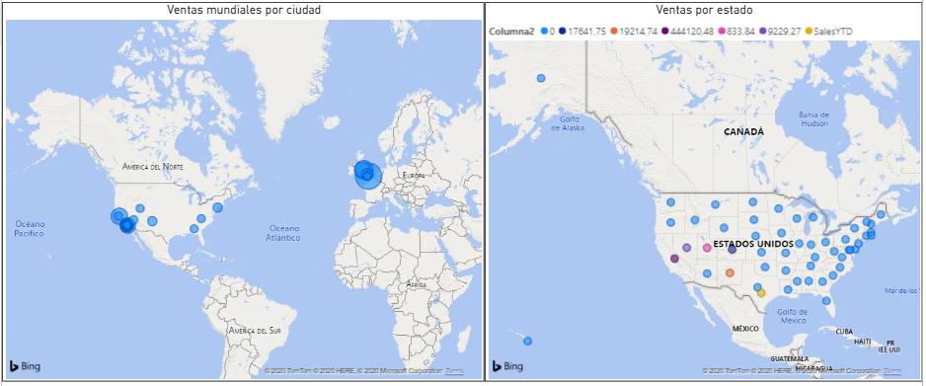

1. Position the cursor on **California(CA)** to see the sales figure. The value has not been formatted as currency.
2. In the **Sales by State** table, click the **SalesYTD** column.
   1. On the **Modeling** ribbon, select **Format:General**, click **Currency**, and then select **$ English (United Stated)**.
   2. Position the cursor on **California(CA)** on the map, and notice that the value has been formatted.
   3. In the **Visualizations** pane, click **Format**, and then expand **Title**.
   4. In the **Title Text** box, type **Sales by State**, and then click **Center**.
   5. Click **Save**, and then leave the report open for the next exercise.

**Results**: After this exercise, you should have created a report that has chart visuals and is ready to publish to the Power BI service.

